**Installing Cisco Packet Tracer**

Select the Application file-

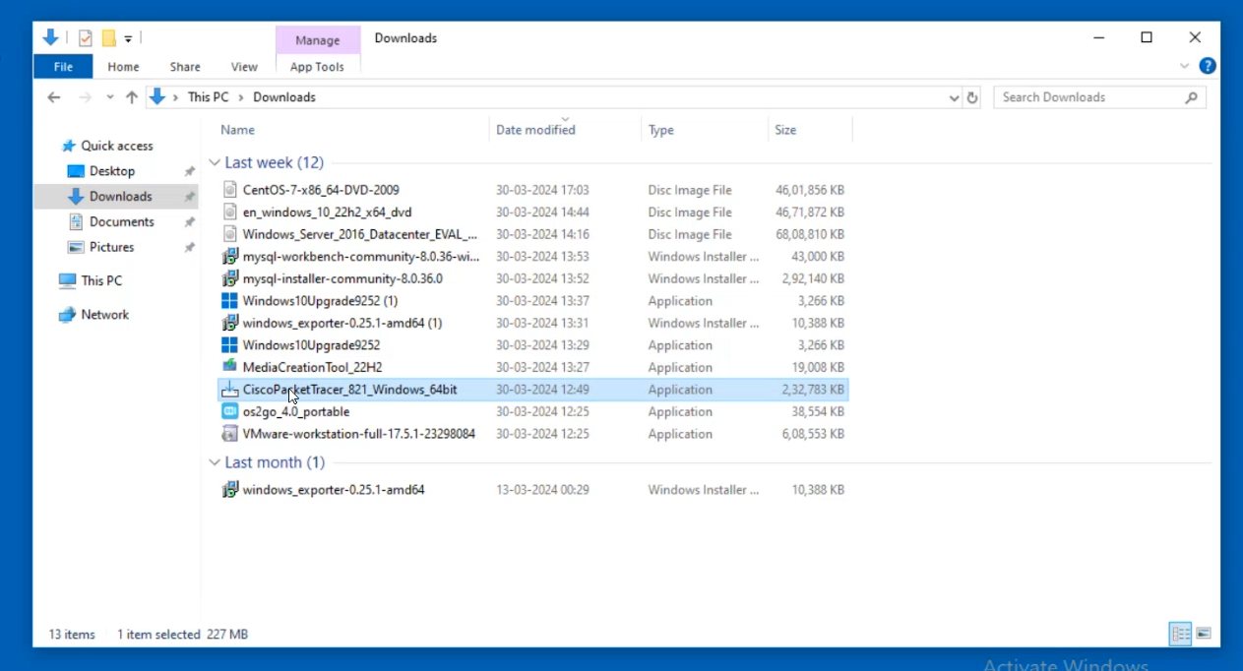

Accept the Agreement-

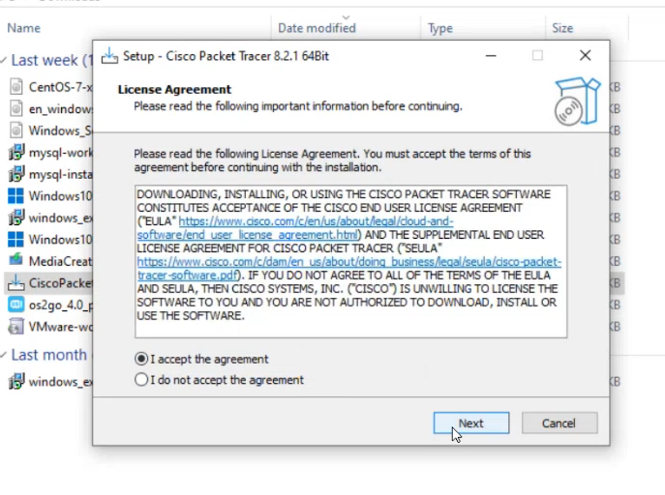

Select the Destination Folder-

This path contains the destination of the file where it will be installed.

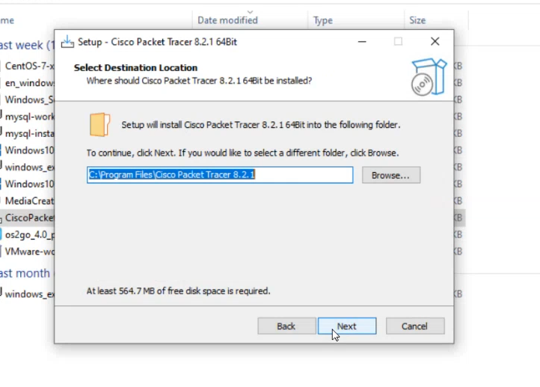

Click on Install-

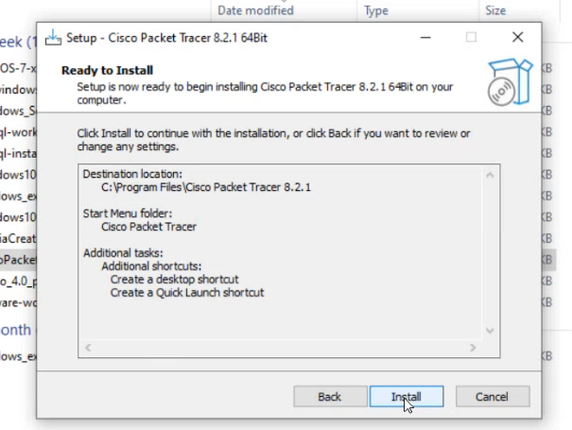

Login with your e-mail id or create new account with sign up option-

.

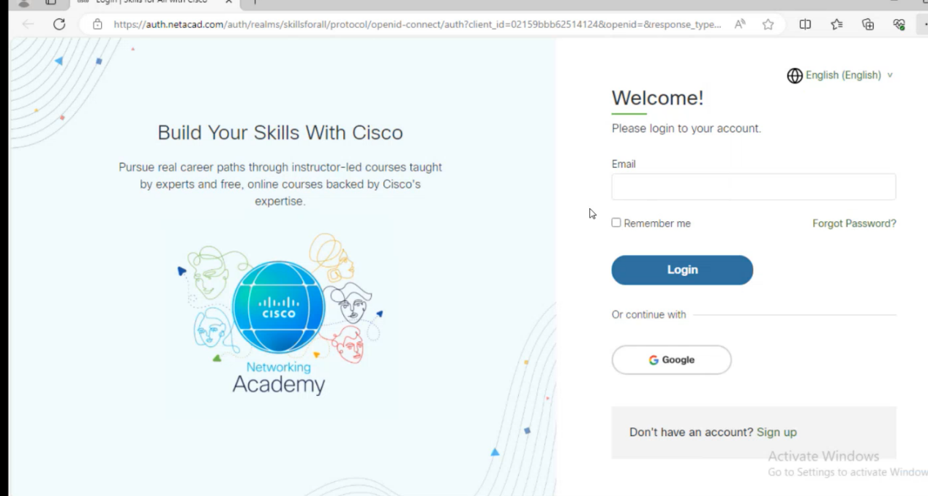

The Interface of the Application-

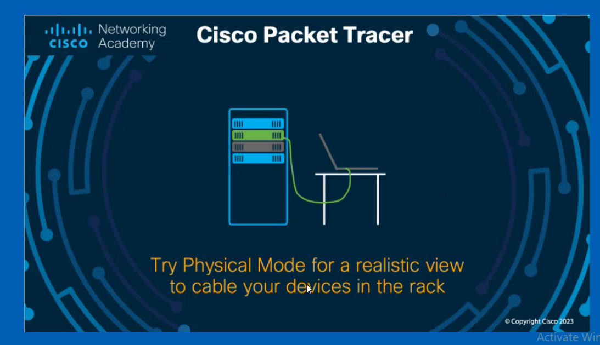

And here we go…

